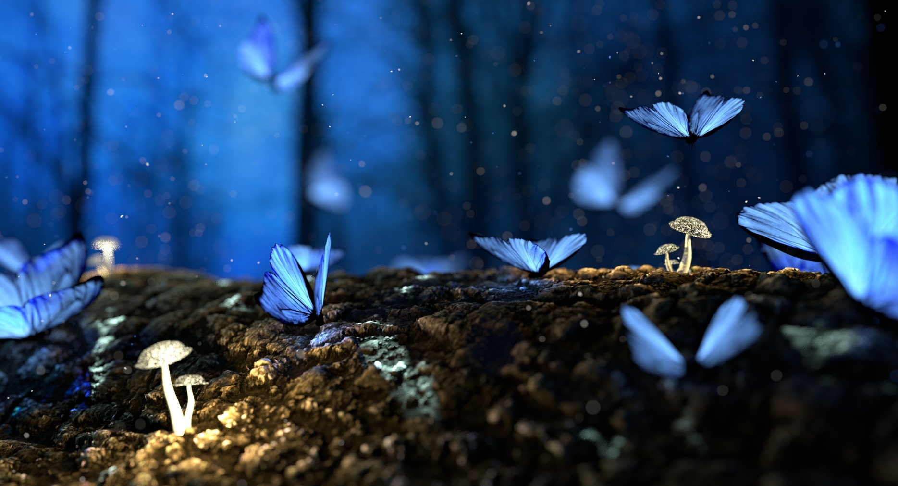

**Showcasing Calendar Prototype**

**IIT Practical Exam**

***January***

|  |  |  |  |  |  |  |
| --- | --- | --- | --- | --- | --- | --- |
| Sun | Mon | Tue | Wed | Thus | Fri | Sat |
|  |  | 1 | 2 | 3 | 4 | 5 |
| 6 | 7 | 8 | 9 | 10 | 11 | 12 |
| 13 | 14 | 15 | 16 | 17 | 18 | 19 |
| 20 | 21 | 22 | 23 | 24 | 25 | 26 |
| 27 | 28 | 29 |  |  |  |  |

|  |  |  |  |  |  |  |
| --- | --- | --- | --- | --- | --- | --- |
| Sun | Mon | Tue | Wed | Thus | Fri | Sat |
|  |  | 1 | 2 | 3 | 4 | 5 |
| 6 | 7 | 8 | 9 | 10 | 11 | 12 |
| 13 | 14 | 15 | 16 | 17 | 18 | 19 |
| 20 | 21 | 22 | 23 | 24 | 25 | 26 |
| 27 | 28 | 29 |  |  |  |  |

***February***

Printable File :

**March 2022**

|  |  |  |  |  |  |  |
| --- | --- | --- | --- | --- | --- | --- |
| **Sunday** | **Monday** | **Tuesday** | **Wednesday** | **Thus** | **Fri** | **Sat** |
| **31** | **1** | **2** | **3** | **4** | **5** | **6** |
| **7** | **8** | **9** | **10** | **11** | **12** | **13** |
| **14** | **15** | **16** | **17** | **18** | **19** | **20** |
| **21** | **22** | **23** | **24** | **25** | **26** | **27** |
| **28** | **29** | **30** | **31** | **1** | **2** | **3** |

Creator: Ujjwal Bhandari